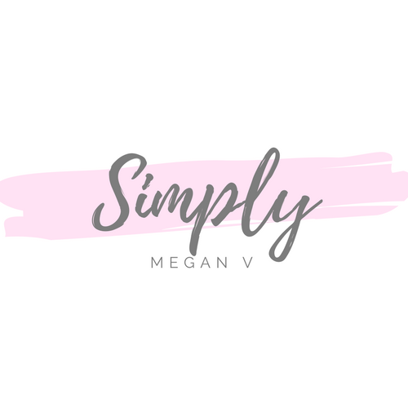
I, _____________________________________________ (name), hereby agree to the following terms and conditions of taking the Simply Megan V course entitled “__Nutrition Coaching Academy___” (the “Certification”):

- I understand and expressly agree that Simply Megan V and/or Megan Vesterdahl does not and cannot guarantee me any results by virtue of taking this Certification;
- I understand and expressly agree that the results from taking this Certification are largely based on my own efforts and actions;
- I understand and expressly agree that this Certification is a training and certification course based solely upon the knowledge, skills, views, and practices of Simply Megan V and/or Megan Vesterdahl;
- I understand and expressly agree that this Certification is not a certification recognized by any state, governing body, or formal licensing agency or organization;
- I understand and expressly agree that this Certification does not and cannot guarantee the requirements to practice nutrition in my home state, nor guarantee that I can practice nutrition in my home state;
- I understand and expressly agree that prior to beginning any type of coaching, practice, or training, I will check the individual laws in my home state;
- I understand and expressly agree that Simply Megan V and/or Megan Vesterdahl is not licensed as any type of doctor, therapist, or medical professional;
- I understand and expressly agree that I cannot and will not replace any advice from a doctor or other licensed medical professional;
- I understand and expressly agree that I will not take on or work with any client(s) who require attention from a licensed professional;
- I understand and expressly agree that taking this Certification and/or implementing its ideas, practices, or theories does not impute any liability to Simply Megan V and/or Megan Vesterdahl for what I choose to teach in my own practice or with my own client(s);
- I understand and expressly agree that I am solely responsible for any actions taken as a result of this Certification course or any knowledge, information, or practices learned therein;
- I understand and expressly agree that Simply Megan V and/or Megan Vesterdahl reserve the right to revoke my Certification after issuance if I am found by Simply Megan V and/or Megan Vesterdahl to be teaching, coaching, or counseling any clients or other persons in any way deemed unsafe or a hazard to the health of the client or persons;
- I hereby release Simply Megan V and/or Megan Vesterdahl from any and all liabilities resulting from my taking of this Certification.

________________________________________________(signature) _________________________(date)

